GitHub link: (includes all the files of the project Lost & Found App, a demo video of it)

[SIT305_homeworks/Task7.1P/look at here at main · JudsonJia/SIT305_homeworks (github.com)](https://github.com/JudsonJia/SIT305_homeworks/tree/main/Task7.1P/look%20at%20here)

The screenshot of the main app screen:

Main page:

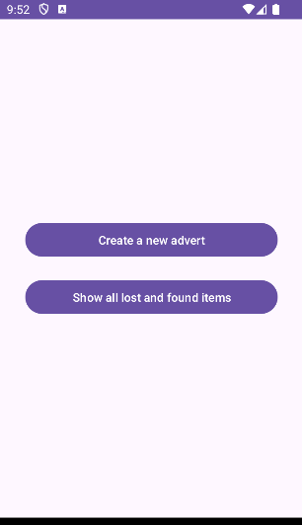

Create_item page:

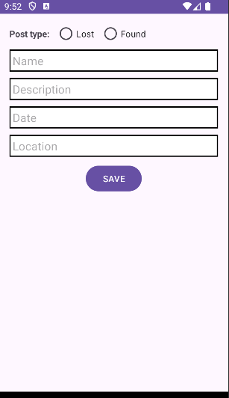

List_items page:

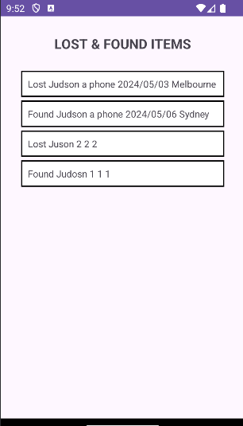

Item_details and remove page:

